EMERGENCY ROOM WAIT TIME PERIOD (CITY WIDE) DATA VISUALISATION

**Data preview:**

1. Histogram of wait times with 30-minute threshold.
2. Bar chart showing proportion of prolonged waits (>=30 min) by triage level.
3. Line chart of average wait time by hour of day.
4. Heatmap of average wait time by hour vs day of week.
5. Pie chart of visit share by mode of arrival (Walk-in / Ambulance / Referral / transfer).
6. Boxplots of wait-time distributions by crowding level (Low / Medium / High).
7. Bar chart of average wait by mode of arrival.
8. Histogram of patient ages.
9. A short report summarizing trends, patterns, and suggested next steps (printed after the charts).

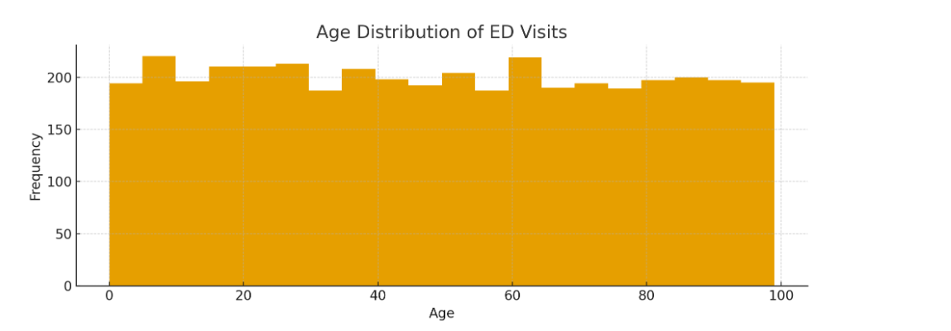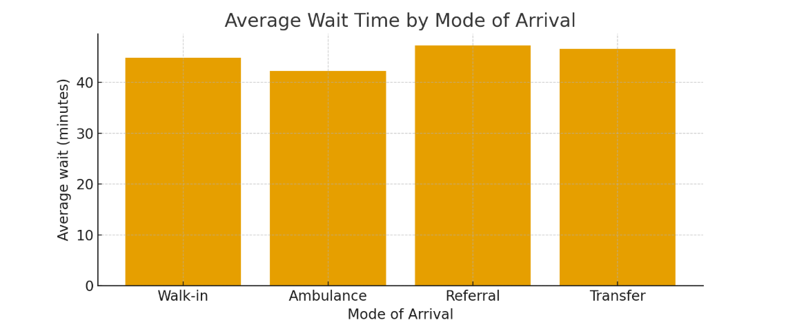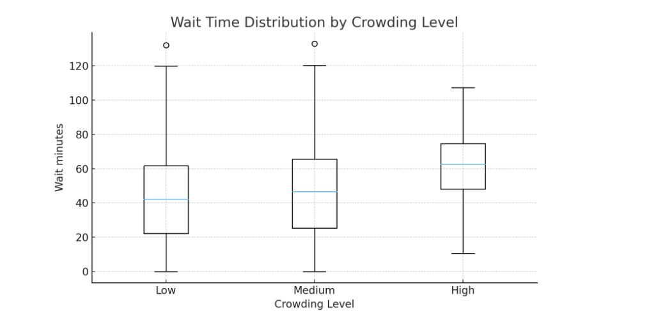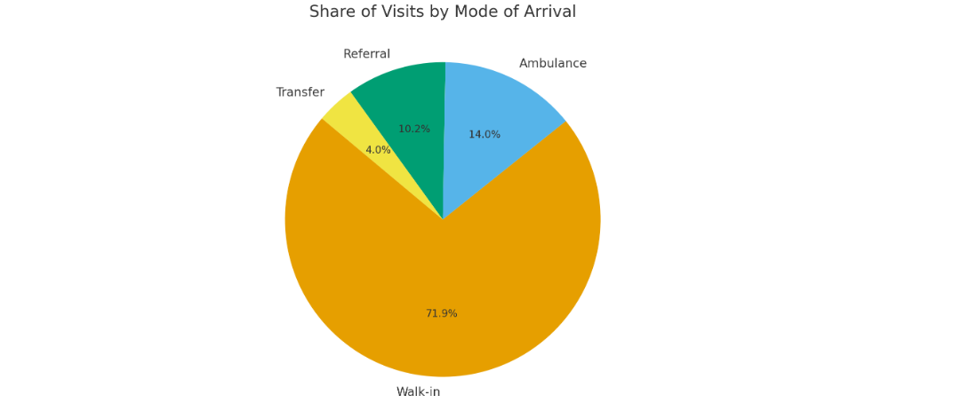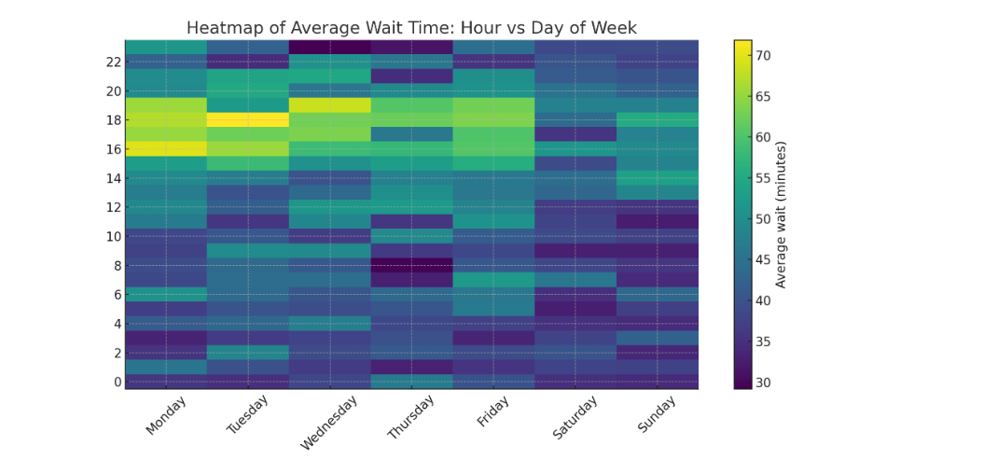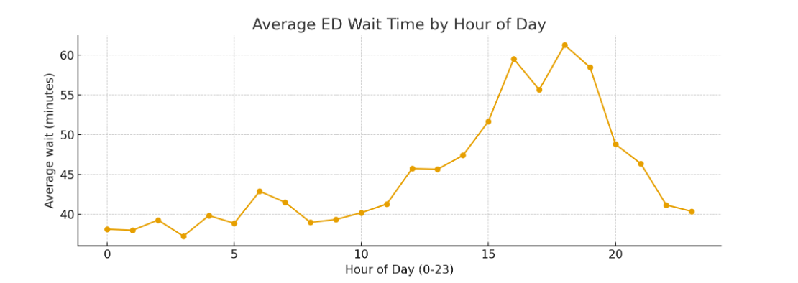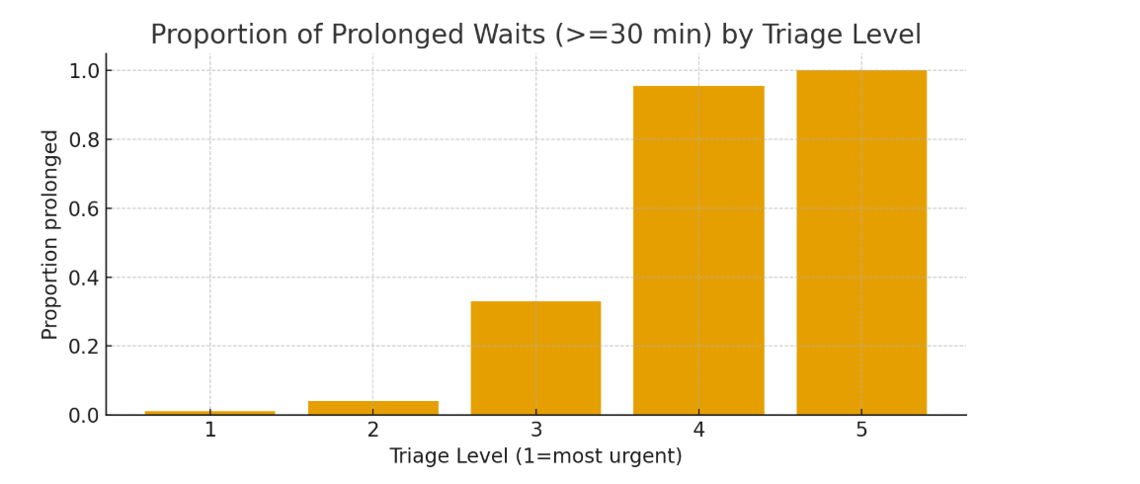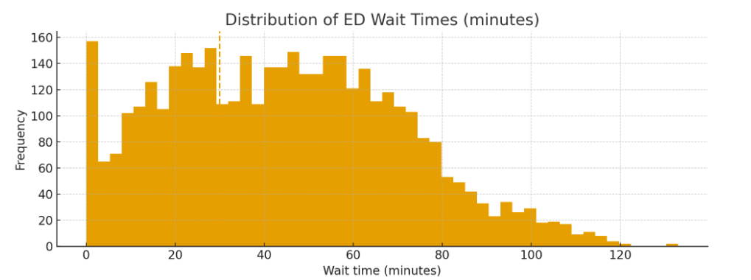

**Short Report – Emergency Department (ED) Wait-Time**

**Analysis**

We analysed a dataset of **4,000 synthetic emergency department visits** that mimics real-world ED patterns (triage levels, arrival modes, hourly and weekday effects, and crowding conditions). Data was cleaned, categorical features were standardized, and a “prolonged wait” label (≥30 minutes) was derived.

**Key Findings from Visualizations:**

1. **Wait time distribution**: Most patients were seen within 30 minutes, but a long tail of prolonged waits exists.
2. **Triage impact**: High-acuity patients (triage 1–2) rarely experienced prolonged waits, while low-acuity patients (triage 4–5) faced much higher delays.
3. **Time-of-day pattern**: Average waits peaked in the **late afternoon to early evening (15:00–20:00)**.
4. **Weekday vs weekend**: **Weekdays**, especially afternoons, showed higher average waits compared to weekends.
5. **Crowding effect**: Under **high crowding**, wait times were significantly longer and more variable.
6. **Mode of arrival**: Ambulance patients were generally seen faster, while transfers/referrals had slightly higher waits.
7. **Demographics**: Patients of all ages were represented; wait times did not vary much by age, but elderly patients had slightly higher admission rates.